Athif Zakiyanto_QE Kelas A

Section 12

1. Challenge Menghitung Luas dan Keliling

package Tugas;  
  
import java.util.Scanner;  
  
class problem1 {  
 private static double lsegitiga(double pan,double tin) { return 0.5 * pan * tin;}  
 private static double ksegitiga(double pan,double tin) { return pan * tin;}  
  
 private static int lpersegi(int sisi) {return sisi * 2;}  
 private static int kpersegi(int sisi) {return sisi * 2;}  
  
 private static int lpersegip(int pan2,int leb2) { return pan2 * leb2; }  
 private static int kpersegip(int pan2,int leb2) { return pan2 * leb2;}  
  
 public static void main(String[] args) {  
 Scanner input = new Scanner(System.*in*);  
 System.*out*.println("====SEGITIGA====== ");  
 System.*out*.print("Masukkan Panjang : ");  
 double pan = input.nextInt();  
 System.*out*.print("Masukkan Tinggi : ");  
 double tin = input.nextInt();  
 System.*out*.println("luas = " + *lsegitiga*(pan,tin));  
 System.*out*.println("keliling = " + *ksegitiga*(pan,tin));  
 System.*out*.println("=====Persegi======");  
 System.*out*.print("Masukkan sisi persegi : ");  
 int sisi = input.nextInt();  
 System.*out*.println("luas = " + *lpersegi*(sisi));  
 System.*out*.println("keliling = " + *kpersegi*(sisi));  
 System.*out*.println("====Persegi Panjang======");  
 System.*out*.print("Masukkan panjang : ");  
 int pan2 = input.nextInt();  
 System.*out*.print("Masukkan lebar : ");  
 int leb2 = input.nextInt();  
 System.*out*.println("Luas = " + *lpersegip*(pan2,leb2));  
 System.*out*.println("keliling = " + *kpersegip*(pan2,leb2));  
  
 }  
}

Output :

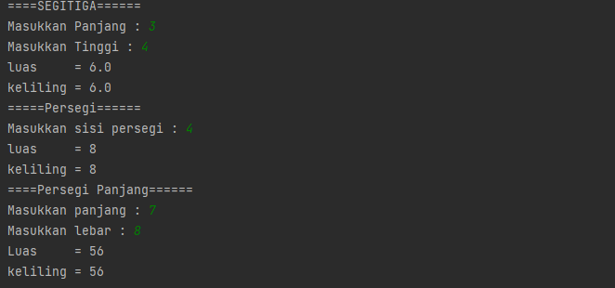

1. Challenge Menghitung volume

import java.util.Scanner;  
  
class problem2 {  
 private static double balok(double lebar,double panjang, double tinggi) {  
 double vol = lebar * panjang * tinggi;  
 return vol;  
 }  
 private static int kubus(int sisi) {  
 int vol = sisi * sisi * sisi;  
 return vol;  
 }  
 private static double tabung(double jar, double tin) {  
 double vol = 3.14 * jar * jar * tin;  
 return vol;  
 }  
  
 public static void main(String[] args) {  
 Scanner input = new Scanner(System.*in*);  
 System.*out*.println("====BALOK====== ");  
 System.*out*.print("Masukkan Panjang : ");  
 double pan = input.nextInt();  
 System.*out*.print("Masukkan Lebar : ");  
 double leb = input.nextInt();  
 System.*out*.print("Masukkan Tinggi : ");  
 double tin = input.nextInt();  
 System.*out*.println("volume = " + *balok*(leb,pan,tin));  
 System.*out*.println("=====KUBUS======");  
 System.*out*.print("Masukkan sisi Kubus : ");  
 int sisi = input.nextInt();  
 System.*out*.println("volume = " + *kubus*(sisi));  
 System.*out*.println("====Tabung======");  
 System.*out*.print("Masukkan Jari-jari : ");  
 double jar = input.nextInt();  
 System.*out*.print("Masukkan Tinggi : ");  
 double ting = input.nextInt();  
 System.*out*.println("volume = " + *tabung*(jar,ting));  
  
 }  
}

Output :

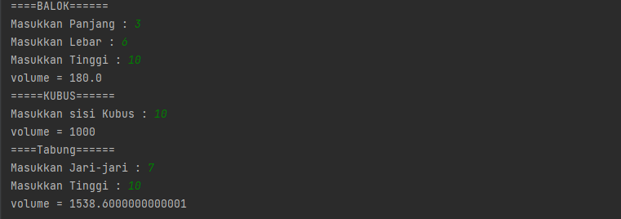

1. Challenge Kalkulator

import java.util.Scanner;  
  
class problem3 {  
 private static int tambah(int a, int b ) {  
 return a + b;  
 }  
 private static int kurang(int a, int b ) {  
 return a - b;  
 }  
 private static int kali(int a, int b ) {  
 return a * b;  
 }  
 private static double bagi(double a, double b ) {  
 return a/b;  
 }  
  
 public static void main(String[] args) {  
 Scanner input = new Scanner(System.*in*);  
 System.*out*.println("=====KALKULATOR====== ");  
 System.*out*.print("Masukan angka 1 : ");  
 double a = input.nextInt();  
 System.*out*.print("Masukkan angka 2 : ");  
 double b = input.nextInt();  
 System.*out*.println("Hasil Pertambahan " + *tambah*((int) a, (int) b));  
 System.*out*.println("Hasil Pengurangan " + *kurang*((int) a, (int) b));  
 System.*out*.println("Hasil Perkalian " + *kali*((int) a, (int) b));  
 System.*out*.println("Hasil Pembagian " + *bagi*(a,b));  
  
 }  
}

1. Challenge Ongkos kirim

import java.util.Scanner;  
class problem4 {  
 private static int volume(int p, int l, int t) {  
 return p * l * t;  
 }  
  
 public static void main(String[] args) {  
 int harga = 0;  
  
 Scanner input = new Scanner(System.*in*);  
 System.*out*.println("====Dimensi Barang====== ");  
 System.*out*.print("Masukkan Panjang : ");  
 int pan = input.nextInt();  
 System.*out*.print("Masukkan Lebar : ");  
 int leb = input.nextInt();  
 System.*out*.print("Masukkan Tinggi : ");  
 int tin = input.nextInt();  
 System.*out*.print("Masukkan berat : ");  
 int kg = input.nextInt();  
  
 problem4 a = new problem4();  
 System.*out*.println("Volume barang =" + a.*volume*(pan,leb,tin));  
  
 if (*volume*(pan,leb,tin) <= 50 && kg <= 1){  
 harga = 5000;  
 System.*out*.println("Harga Ongkir =" + harga);  
 }else {  
 harga = 10000;  
 System.*out*.println("Harga Ongkir =" + harga);  
 }  
 }  
 }

Output :

